*SCATS Application*

Design documentation

Version *1.0*

*01/19/2020*

Contents

Class Architecture Diagram 3

Object Data Model 3

Object Data Model in Detail 4

Data Design Diagrams 9

Database Design 9

Database Management Class 10

Visual Design Diagrams 11

Visual Mockup 11

### Class Architecture Diagram

The SCATS solution is based upon the management and interaction between five primary data classes; Consultant, Certification, Document, Assignment, and Report. The Consultant data model defines each individual consultant added to the SCATS system for management and tracking. Because consultants can only be assigned engagements if they’re qualified and certified, the Certification data model will be used to outline each certification obtained by the consultant. Certifications data fields track the certification name, its type, license number, acquisition date, status, and expiration date.

An Assignment data model is used to define past, active, and future assignments that will be undertaken by qualified consultants. The Document data model will be used to define the necessary documentation records for an assignment, ensuring all legal and regulatory compliance needs are set prior to active engagement. Likewise, a Report data model will be used to define the reports generated as an assignments status transitions from “Active” to “Reporting”.

### 

### Object Data Model

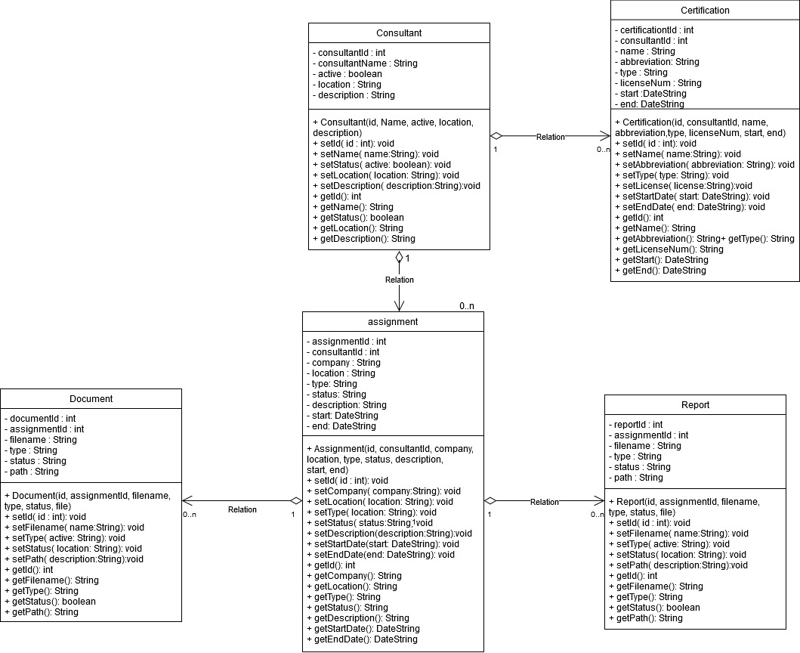

### Object Data Model in Detail

#### Consultant Data Model

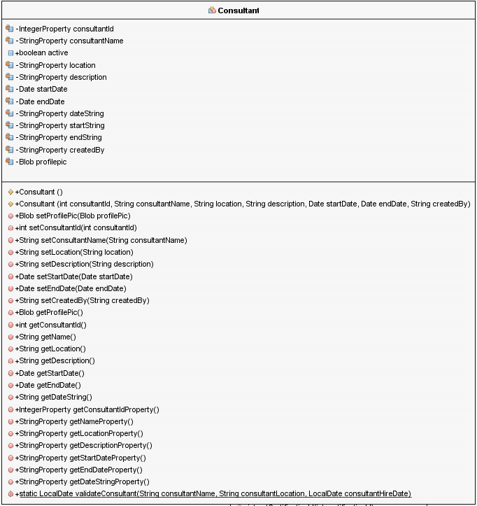

#### Assignment/Engagement Data Model

#### 

#### Certification Data Model

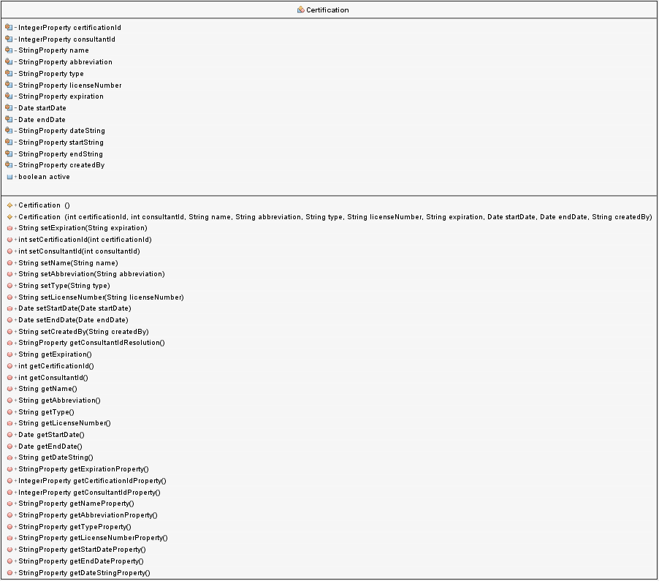

#### Document/Reports Data Model

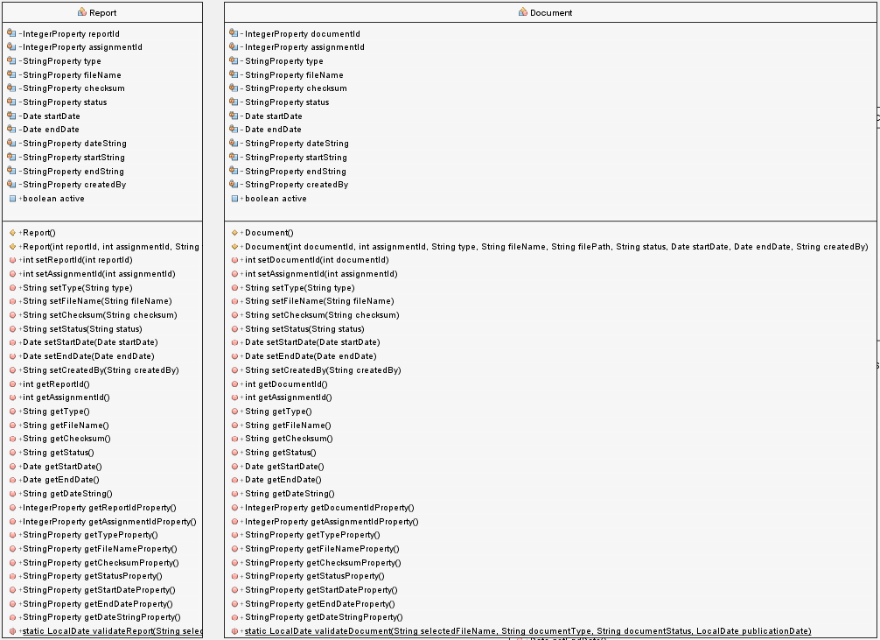

#### System User Data Model

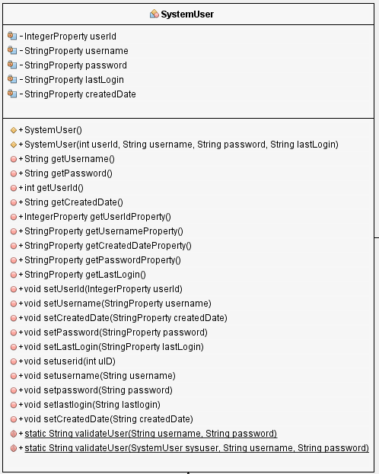

### Data Design Diagrams

### Database Design

The backend SQL database consists of five data tables detailing the data descriptions of a system users, managed consultants and their certifications; assignments, pre-assignment documents, and reports generated upon completion. The “system_user” table will serve to manage users authorized to access the application and database. The “consultant” table will have a many-to-one relationship with the “system_user” table and serve to manage consultants to be tracked and managed. Certifications of consultants will be recorded and tracked within the “certification” table, ensuring all consultants have valid, active, and industry approved security certifications. When consultants are put on assignment, the “assignment” table will be used to maintain assignment/engagement records along with the “document” table, used to store documents associated with the assignment. Finally, the report table, with a many-to-one relationship with the assignment table, will be used to store reports generated upon the completion of an assignment.

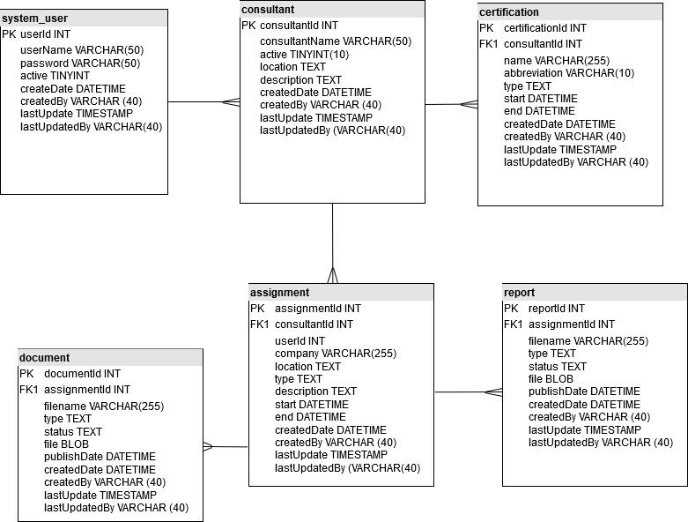

### Database Management Class

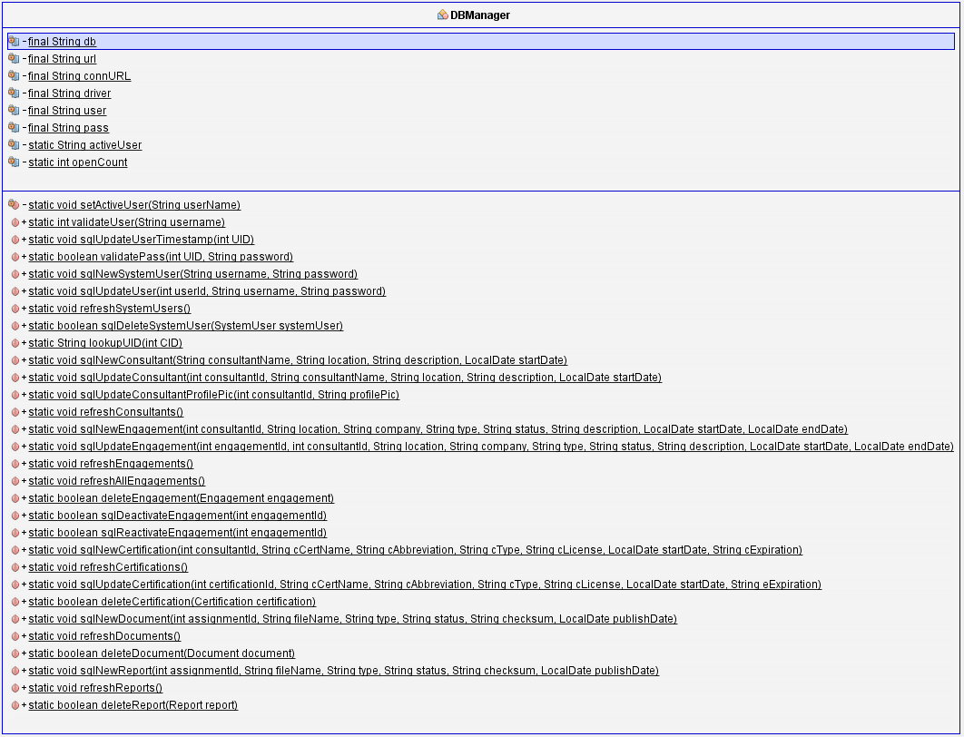

### Visual Design Diagrams

### Visual Mockup

The main screen of the SCATS application will provide the user with a graphical representation of the current month’s engagement/assignment schedule. Active assignments/engagements will span the scheduled length of time on the calendar and provide additional detail of the engagement upon a mouse click event.

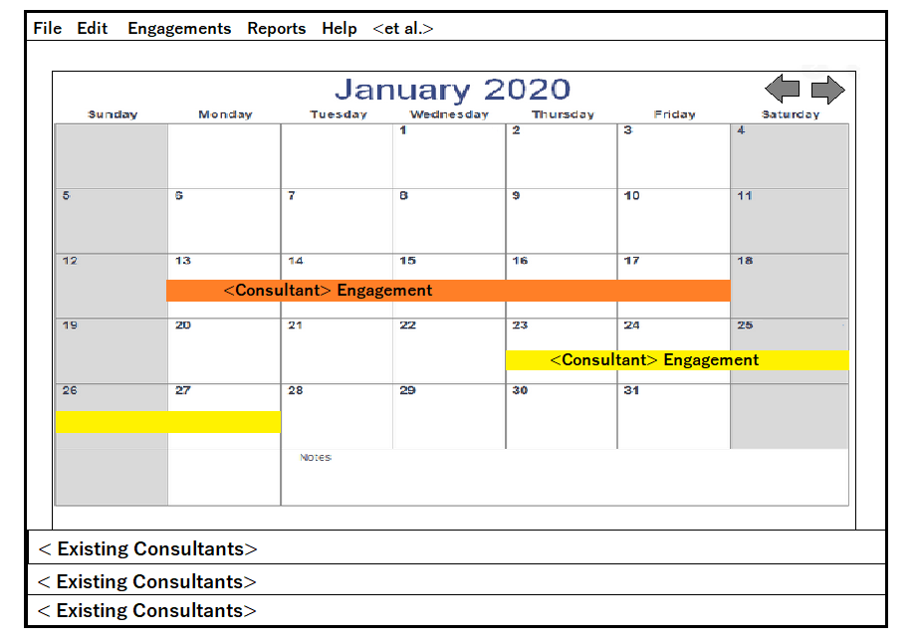

When clicked upon, a popup window will appear that will show the consultant assigned to the engagement, the type of engagement (Network, Web, Redteam, Social Engineering, Development, etc.), the location, the duration, associated documentation (Rules of Engagement (RoE), Statement of Work (SoW), etc.) and the hours of approved active operation.

